CPSC 488 Group 1 Installation Manual

Overview

This document will describe, in detail, what is needed to, and how to run this work order system project.

1. System Requirements
2. Assumptions

* This project assumes users will run on the latest version of Java using Eclipse IDE
* It also assumes running on a Windows 10 environment.
* Access to the internet and a Google Chrome account
* A basic internet browser such as Chrome or Firefox

1. Setting up SMTP

For proper use of this project, emails are sent out to users when they register, send an incident report, and then they will also get notified when their incident is updated or completed. And with this in mind a Gmail account will need to be made so that the emails have a source.

So, within the project there is a part of the application.properties file which will need the email username and password set up, but the password used normally both should not be used and will not work with the project. Here are the steps to get a proper application specific password for use with this system. Going to your account within the browser and typing “App Passwords and hitting the setting labeled as such with get you to the proper location

Hitting the “Select app” drop down and then hitting “other” will give you a text box in which you can create a name for the password, create the name, and then selecting generate will give you the key needed. The password will then show up in a yellow text box, take it and place it in the project's application.properties file, and depending on which one, both will need it (more in “important classes and files” section). (the red attributes are for the email and app specific password; while the blue is for the mySQL password)



RUNNING THE PROGRAM

But before the project can be ran, two things will need to be done:

1. Changning the password to access mySQL. Inside of the src/main/resources file you will see this:

Open up the application.properties file and change the “spring.datasource.password” field to that of the password used to access mySQL on that computer



Once that is properly set, the next step is…

1. Configuring the build path of the project:

For reasons unbeknownst to our group, we have continued to run into this bug with the project, with no information available for a permanent solution. However, the solution is simple and works for as long as the project does not get updated via the “Update project” button under the “Maven” tab.

Anyway, the solution is as follows:

1. Right click the folder that says “WorkOrders” and select “Build Path” 🡪 “Configure Build Path” Graphical user interface, application

   Description automatically generated

And when in this window, move over to the “Source” tab, and under the section that says WorkOrders/src/main/resources, click on the funnel shape that says “Excluded: **” and then click remove on the right side. Graphical user interface, text, application

If done correctly it will then say (None), hit “Apply and Close and you’re ready to run the program! Simply run the WorkOrdersApplication.java file as a Java Project; and it should run without errors. And the entire console will look like this once the program is running: Text

Now head to “localhost:8080” in your perffered serach engine to see a login screen, and from here, you will be shown all roles within our project, an overview of what they can do within the project, all with descriptions and screenshots from the project itself.\

Our project has support for both mySQL or the memory-based H2 database system, both can be used, it is fully up to the user to decied which they want, it is just a matter of taking the proper .txt file information and copy-pasting the information into the application.properties folder (note: the use of H2 is highly discouraged, as any informaiton in the database is lost on program termination, whereas mySQL will have persistant data). Both are explained below:

mySQL

With the mySQL information into the application.properties file, make sure the username and password are properly set up, and a schema called ‘workorders’ should be created with tables for USERS and INCIDENTS when the program runs.

If setup for mySQL it should look like below:

* 1. H2

With the H2 information in the application.properties folder, the only matter that the user will have to do is go to localhost:8080/h2-console to see what the database has, and remember to copy and paste the datasource url and ensure the drive class name is correct in the browser; there are ours below:



1. Now you need to run the WorkOrdersApplication.java file as a java application:

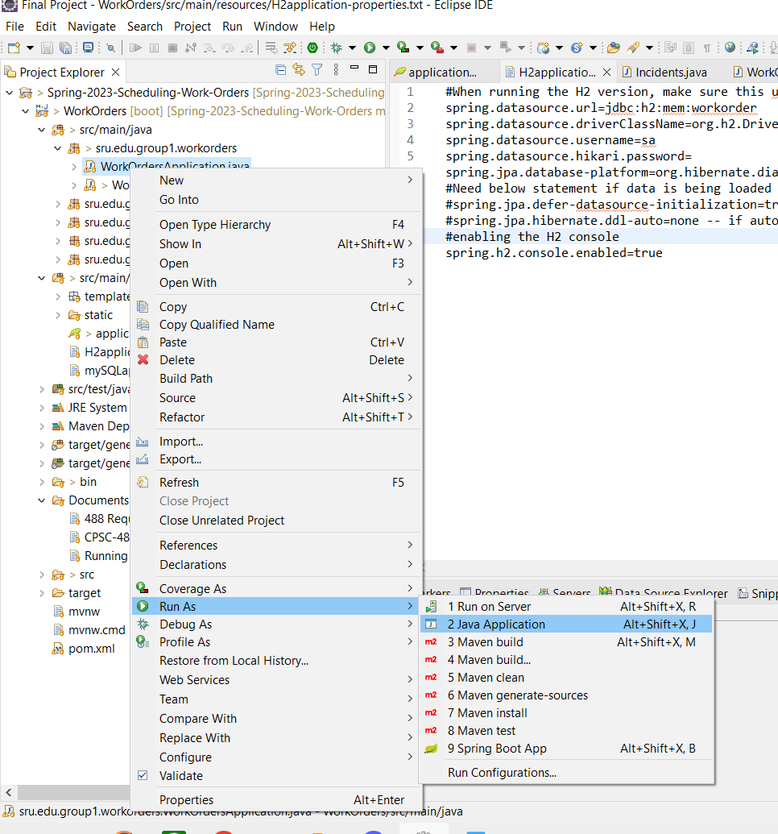

1. After Running this, open your web browser and go to localhost:8080. You should be greeted by this page.

1. **At this point you can choose to register a new user account or login**